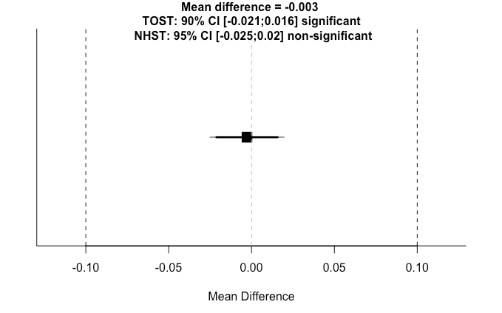

*Figure 1*. Purpose in Life TOST results for factor loadings.

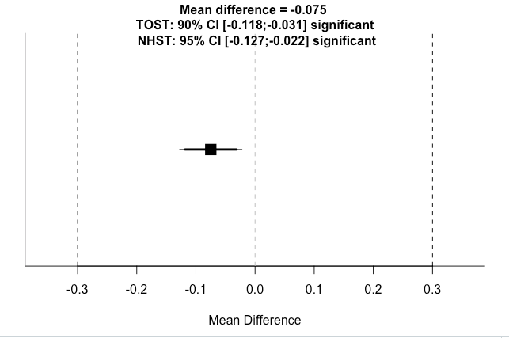

*Figure 2*. Purpose in Life TOST results for item means.

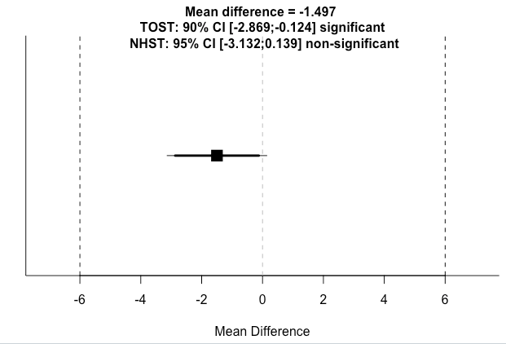

*Figure 3*. Purpose in Life TOST test for total scores.

Image 4 Factor Loadings LPQ TOST

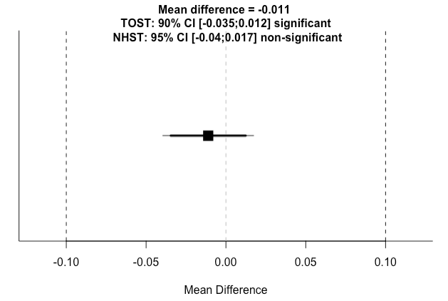

*Figure 4*. Life Purpose Questionnaire TOST test for factor loadings.

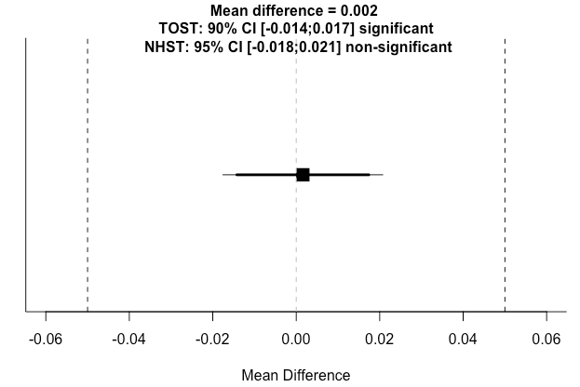

*Figure 5*. Life Purpose Questionnaire TOST test for item means.

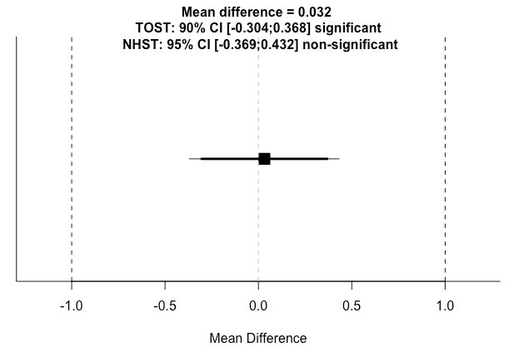

*Figure 6*. Life Purpose Questionnaire TOST test for total scores.